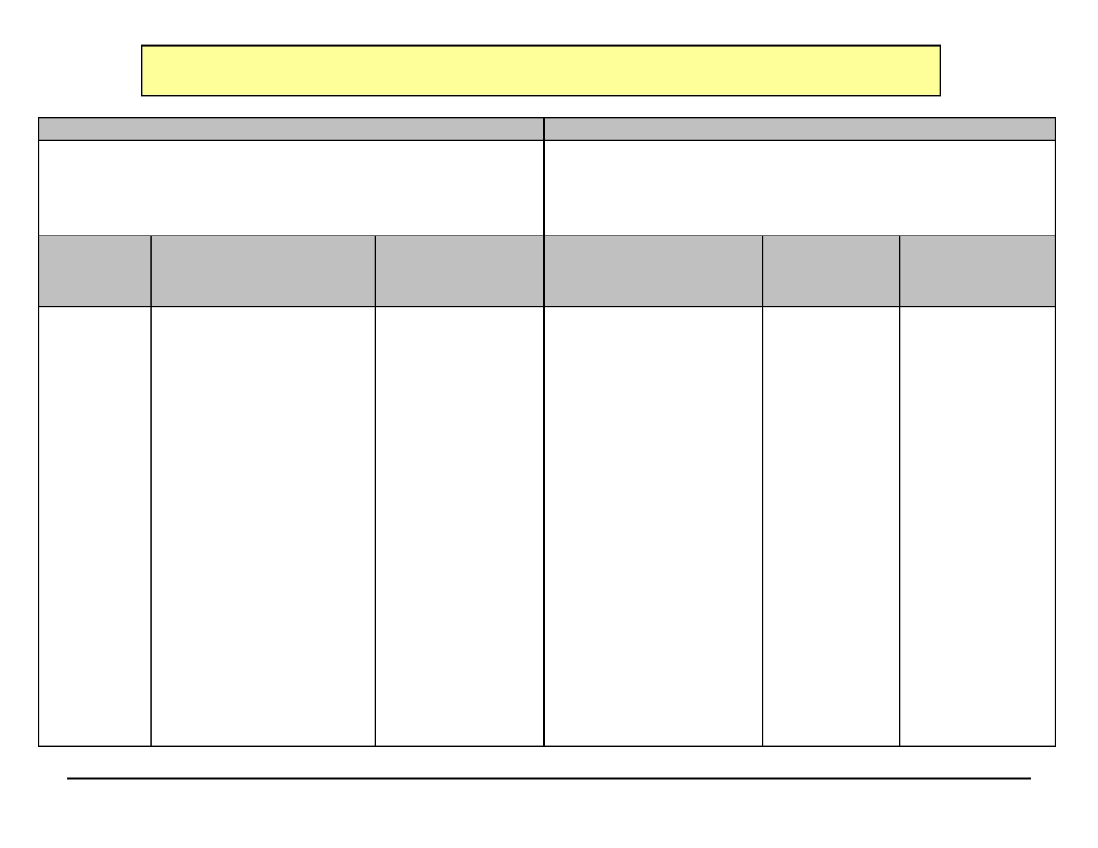
Greenwich-Stow Creek Partnership Schools
Content Area: Spanish Grade: 6th

Big Ideas Standard

Language and culture are mutually interdependent.
Communication is the ability to understand and be understood in real world situations.
7.1 All students will be to communicate at a basic literacy level in another
language other than English.
7.2 All students will be able to understand the interrelationship between language and culture.

Program Components

Learning Enduring Understandings Essential Questions Areas of Focus Assessments (Learning Activities)
Progressions (Indicators)

Interpretive
Mode
7.1.NH.A.1 7.1.NH.A.2 7.1.NHA.3 7.1.NMA.4 7.1NH.A.5

Learning about family traditions allows for a better understanding
of similarities and differences across cultures.

Learning about folktales, fables a
and literature illustrates aspects
f a culture in a way that captures

How does learning about
family traditions and
structures help to
understand culture?

How does learning about
Hispanic folktales,
fables and literature help

•

•

Learn to name and
identify family members
in the target language.

Students learn to
describe their own
family

Teacher made tests and quizzes.

Conversational case scenarios

Design an
imaginary/real

•

•

Students work
in pairs to
formulate a family tree

Memory games to reinforce

Interpersonal the imagination.
Mode
to acquire a better
knowledge of other
•
Students learn about
Hispanic family
family tree and
label with the
information.

7.1NH.B.1
7.1NH.B.2 7.1NM.B.3 7.1NH.B.4 7.1NH.B.5

Presentational
Mode
7.1NM.C1 7.1NM.C2 7.1NH.C3 7.1NM.C4 7.1NM.C5

Interpretive
Expanding language through
additional vocabulary helps to
enhance communication and fluency.
cultures?

How does acquiring
additional vocabulary
help to build a
foundation for fluency?

•

•
traditions through literature.

Students listen to stories
about the Mayans,
Aztecs, Incas and other indigenous cultures and
their contributions to humanity.

Learn to state the date,
weather, and seasons
vocabulary learned

Class presentations Student reflections
and class
discussions

Role play

Alphabet book
project

Menu project

Architecture
•

•

•

•
Students copy
family
vocabulary.

Stories about
families
within cultural
contexts are read.

Students copy
vocabulary

Games, songs,

Greenwich-Stow Creek Partnership Schools 1 2013

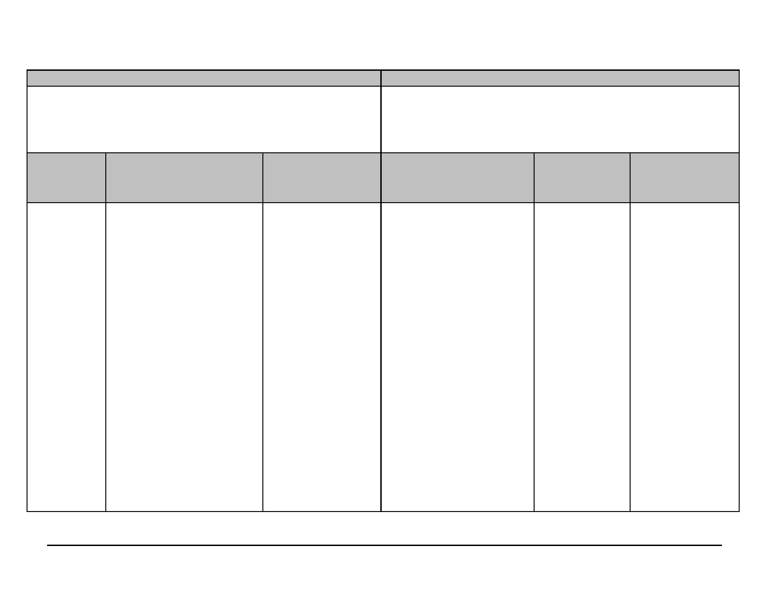
Big Ideas
Language and culture are mutually interdependent.
Communication is the ability to understand and be understood in real world situations.
Standard
7.1 All students will be to communicate at a basic literacy level in another
language other than English.
7.2 All students will be able to understand the interrelationship between language and culture.

Program Components

Learning Enduring Understandings Essential Questions Areas of Focus Assessments (Learning Activities)
Progressions (Indicators)

Mode • Learn to name and project and play skits
7.1.NM.A.1 identify animal names.

7.1.NH.A.2 7.1.NM.A.3 7.1.NM.A.4 7.1NH.A.5

Interpersonal
Mode

7.1NM.B.1 7.1NH.B.2 7.1NM.B.3 7.1NM.B.4 7.1NH.B.5

Presentational
Mode
7.1NM.C1 7.1NM.C2 7.1NH.C3 7.1NM.C4 7.1NM.C5

•

•

•

•

•

Learn to identify class
objects

Expand on knowledge about numbers, colors,
transportation, and house vocabulary

Expand on food vocabulary.

Expand knowledge on
sports and outdoor
activities

Build vocabulary about
careers /professions
•

•

•
Internet sites

Spanish/
English
dictionary

Teacher created
worksheets

Greenwich-Stow Creek Partnership Schools 2 2013

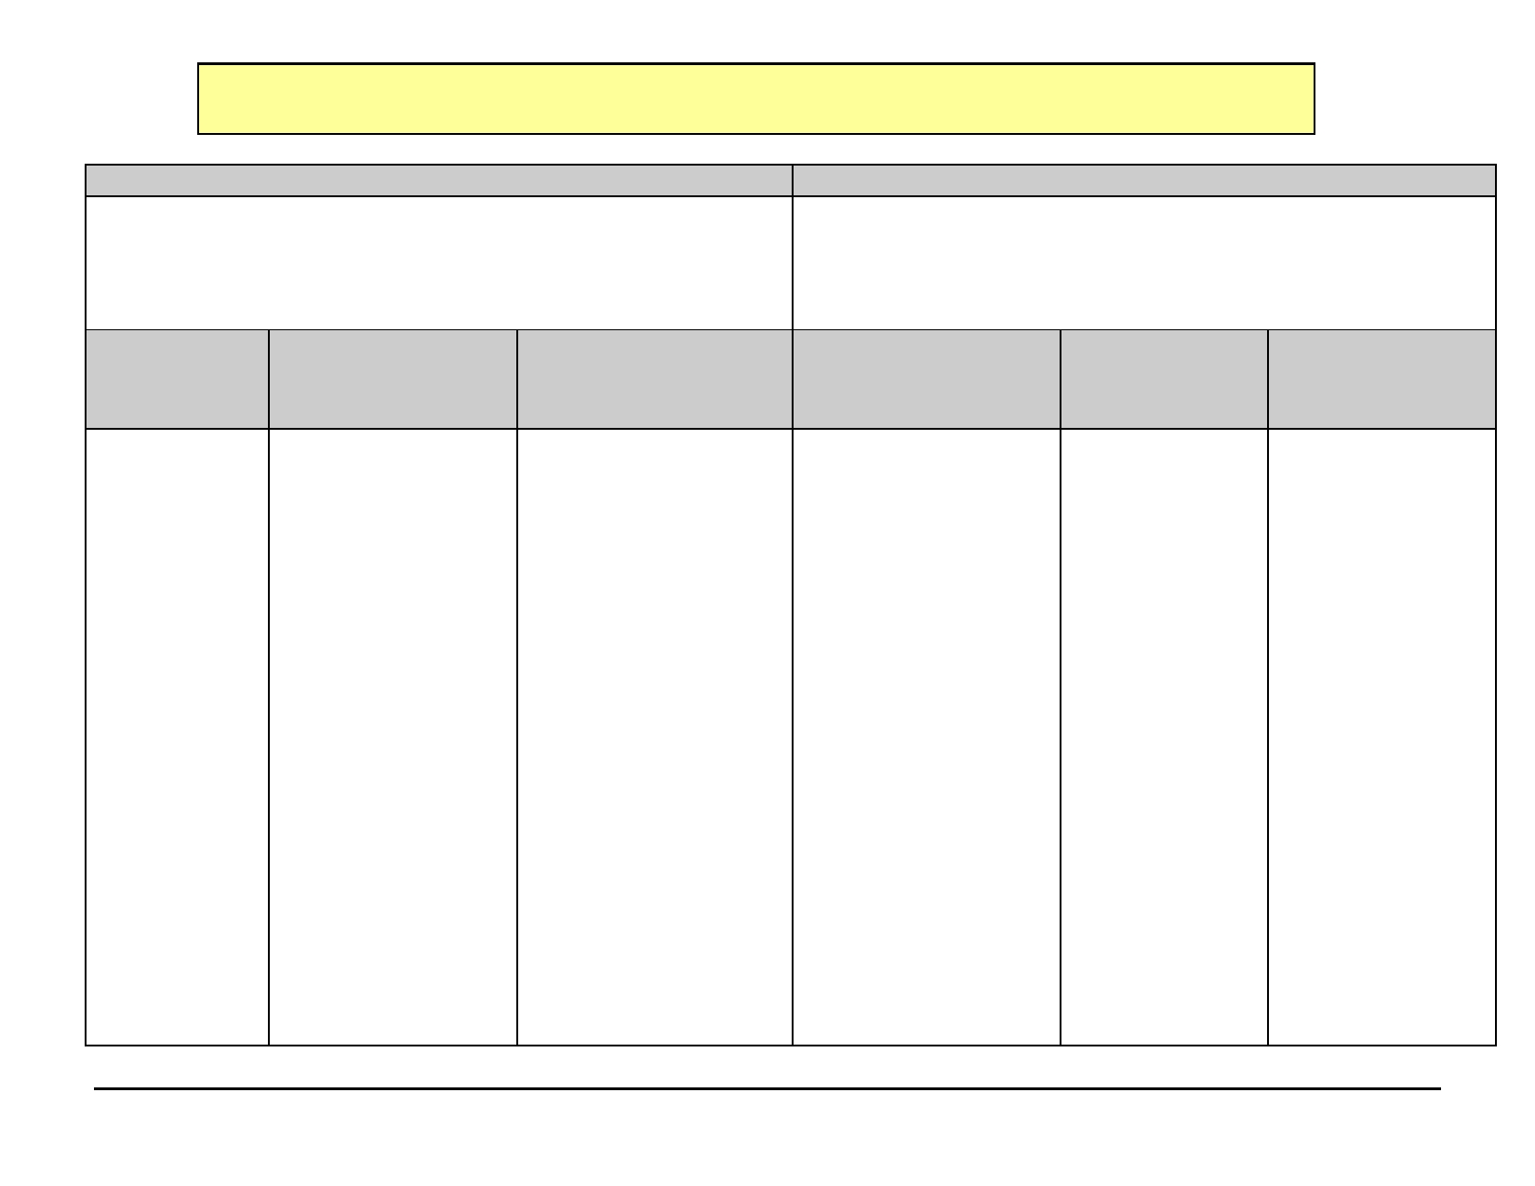
Greenwich-Stow Creek Partnership Schools

Content Area: World Language Spanish

Big Ideas
Language and culture are mutually interdependent.
Communication is the ability to understand and be understood in real world situations.
Grade: 7th

Standard
7.1 All students will be to communicate at a basic literacy level in another
language other than English.
7.2 All students will be able to understand the interrelationship between language and culture.

Learning
Progressions

Interpretive
Mode
7.1.NH.A.1 7.1.NH.A.2 7.1.NHA.3 7.1.NMA.4 7.1NH.A.5

Interpersonal
Mode
7.1NH.B.1 7.1NH.B.2 7.1NM.B.3 7.1NH.B.4 7.1NH.B.5

Presentational
Mode
7.1NM.C1 7.1NM.C2 7.1NH.C3 7.1NM.C4 7.1NM.C5
Interpretive
Mode

Enduring
Understandings

Learning simple
greetings and
courtesies allows for
enhanced
communication in the target language.

Developing
knowledge about
travel vocabulary can maximize expressing needs when traveling in Spanish speaking
countries?

Learning about telling
time in the target
language provides means of adjusting
one's own schedule to the environment.

Essential Questions

How does learning and
practicing culturally
authentic phrases help to
bridge positive
communication between
different cultures?

How does learning traveling
vocabulary help to facilitate a
more comprehensive
traveling experience and
increase better
communication between all
parties?

How does learning to tell time correctly in the target
language help to broaden the
scope of conversation and
respond to structured
scheduled environments?

How does learning about
different types of
architectural formats in

Areas of Focus
(Indicators)

Practice conversational
language (My name
is____, How are you?___.
What is the weather?,
Please/Thank you, Yes/No).

Respond to common
greetings and expressions.

Translate Spanish
vocabulary into English.

Learn to identify airport
signs, traveling
documents, common phrases, lodging and
other travel vocabulary.
Expand vocabulary
related to places and things.

Assessments

Cartoon project
and presentation

Work in pairs to
practice greetings
and expressions

Role playing

Teacher made
tests and quizzes.

Conversational case scenarios.

Design and label
a three
dimensional
house in a shoe
box. Label house
items in the
target language.

Program Components
(Learning Activities)

Students practice a dialogue skit.

Computer clip art and
/or drawings are used to
formulate the cartoon

Internet sites

Students copy power
point presentation.

Memory games with
flash cards to enhance
knowledge

Students practice
writing numbers and simple math.

Work in pairs to tell time.

Judy clocks are used as a class to tell time as a

Greenwich-Stow Creek Partnership Schools 3 2013

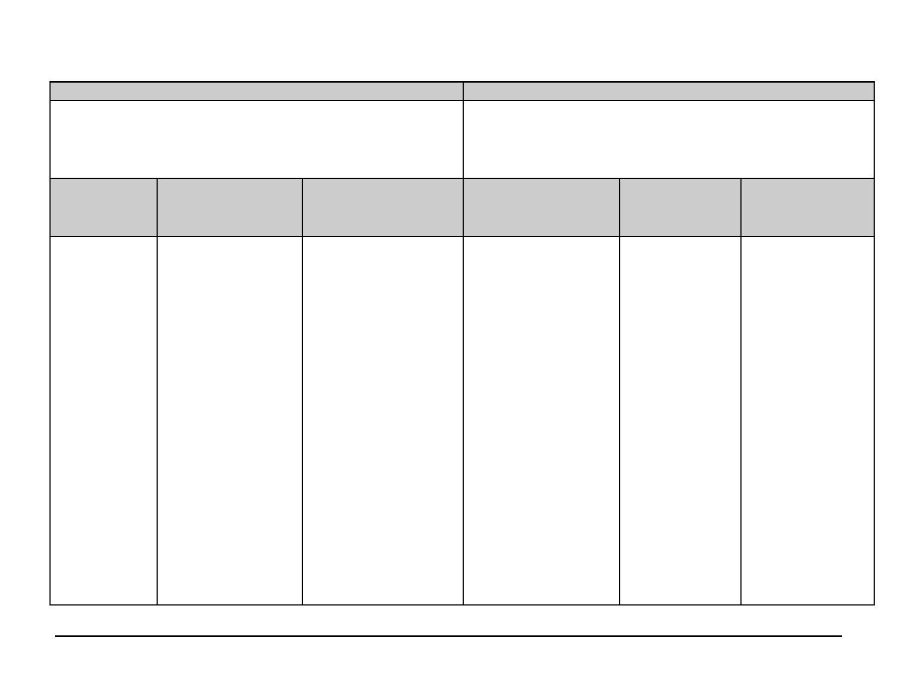
Big Ideas
Language and culture are mutually interdependent.
Communication is the ability to understand and be understood in real world situations.
Standard
7.1 All students will be to communicate at a basic literacy level in another
language other than English.
7.2 All students will be able to understand the interrelationship between language and culture.

Learning
Progressions

7.1.NH.A.1 7.1.NH.A.2 7.1.NHA.3 7.1.NMA.4 7.1NH.A.5

Interpersonal
Mode

7.1NH.B.1 7.1NH.B.2 7.1NM.B.3 7.1NH.B.4 7.1NH.B.5

Presentational
Mode
7.1NM.C1 7.1NM.C2 7.1NH.C3 7.1NM.C4 7.1NM.C5

Enduring
Understandings

Exposure to architectural terminology
provides a greater
insight into culture.

Essential Questions

Spanish speaking countries
help students develop a better understanding of culture and
ways of life?

What are some similarities
and differences related to housing and architectural
designs in Spanish speaking
countries as compared to
those of the United States?

Areas of Focus
(Indicators)

Learn vocabulary words related to transportation.

Expand knowledge of
numbers and simple math to learn to tell time.

Learn to tell time to the
hour, minute and second.

Students practice telling
time by developing a schedule of their daily activities.

Expand vocabulary
words related to
furniture and household items.

Students read about an
array of common
architectural designs

Assessments

Program Components
(Learning Activities)

group.

Role play skits.

Write current class
schedules and tell time in the target language.

Students work in pairs
to design a house
utilizing a variety of
materials such as:
construction paper,
computer clip art,
miniature furniture and drawings.

Greenwich-Stow Creek Partnership Schools 4 2013

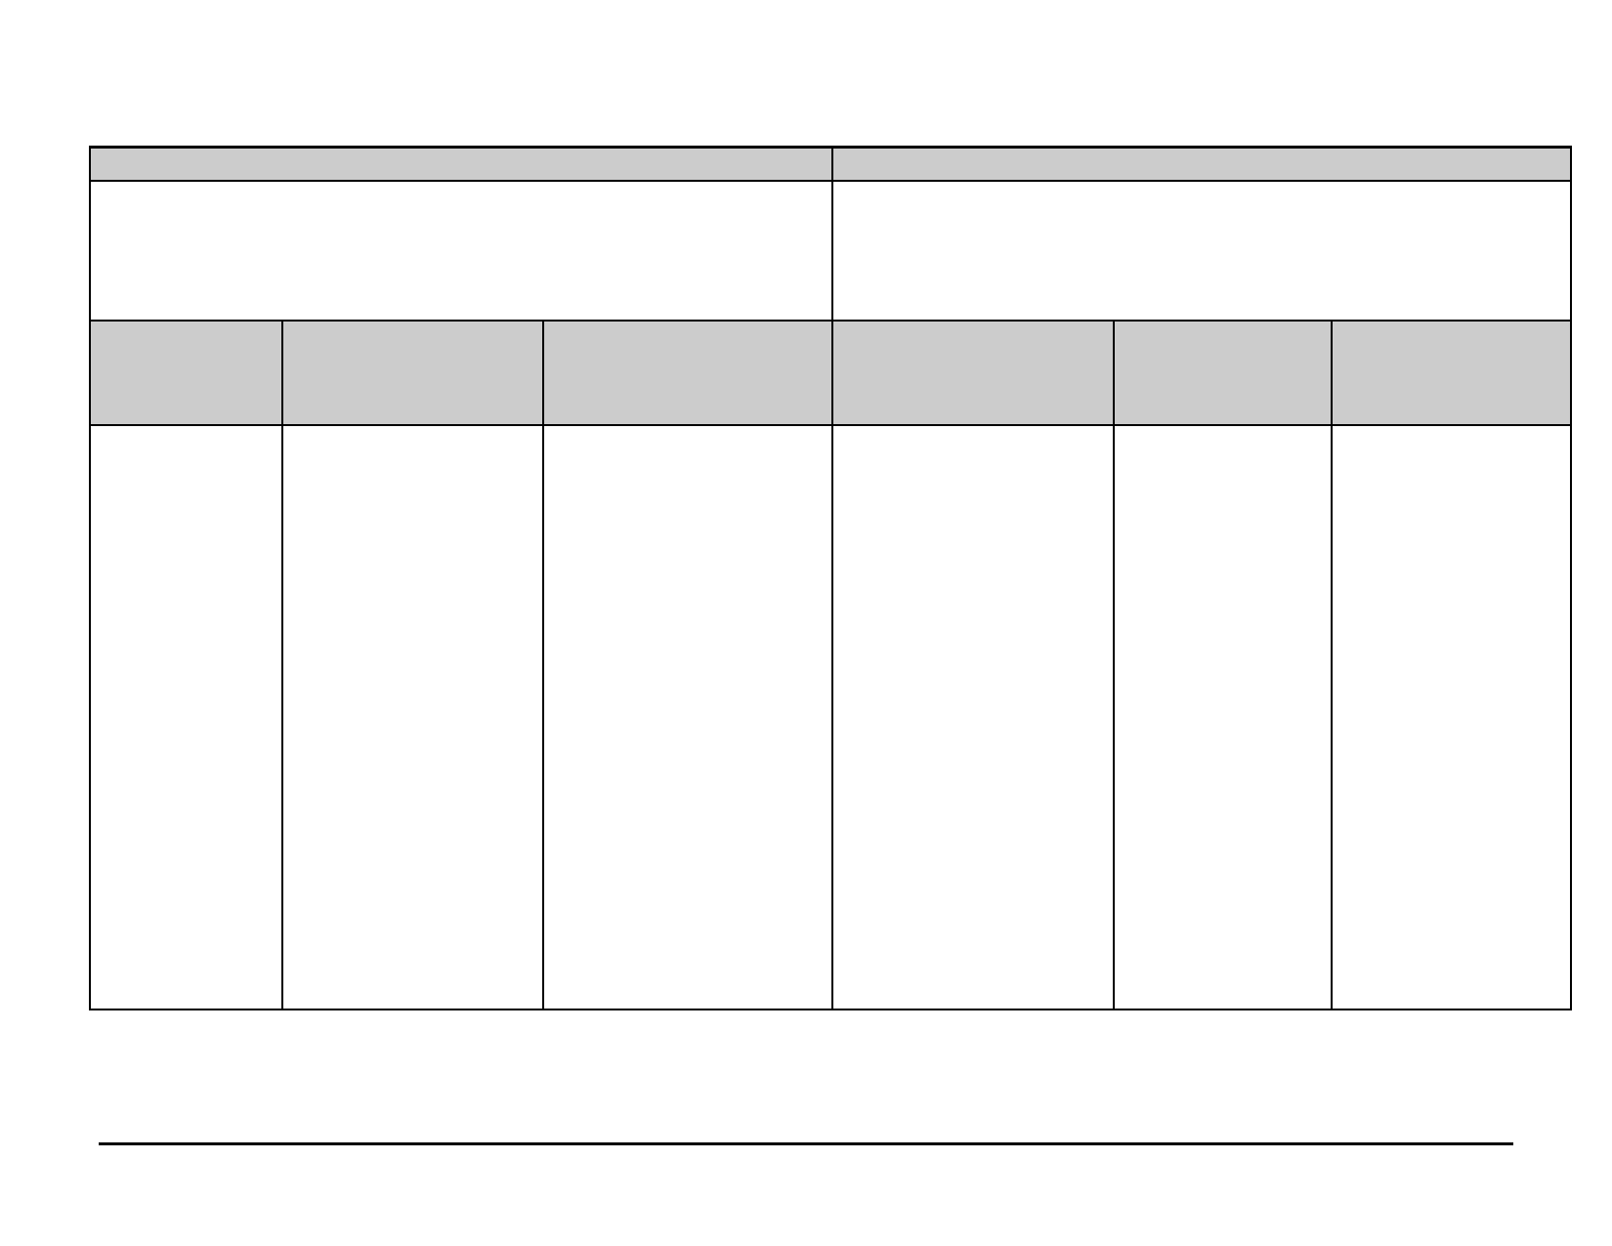
Big Ideas
Language and culture are mutually interdependent.
Communication is the ability to understand and be understood in real world situations.
Standard
7.1 All students will be to communicate at a basic literacy level in another
language other than English.
7.2 All students will be able to understand the interrelationship between language and culture.

Learning Enduring Essential Questions Areas of Focus Assessments Program Components Progressions Understandings (Indicators) (Learning Activities)

such as the plaza and others.

Greenwich-Stow Creek Partnership Schools 5 2013

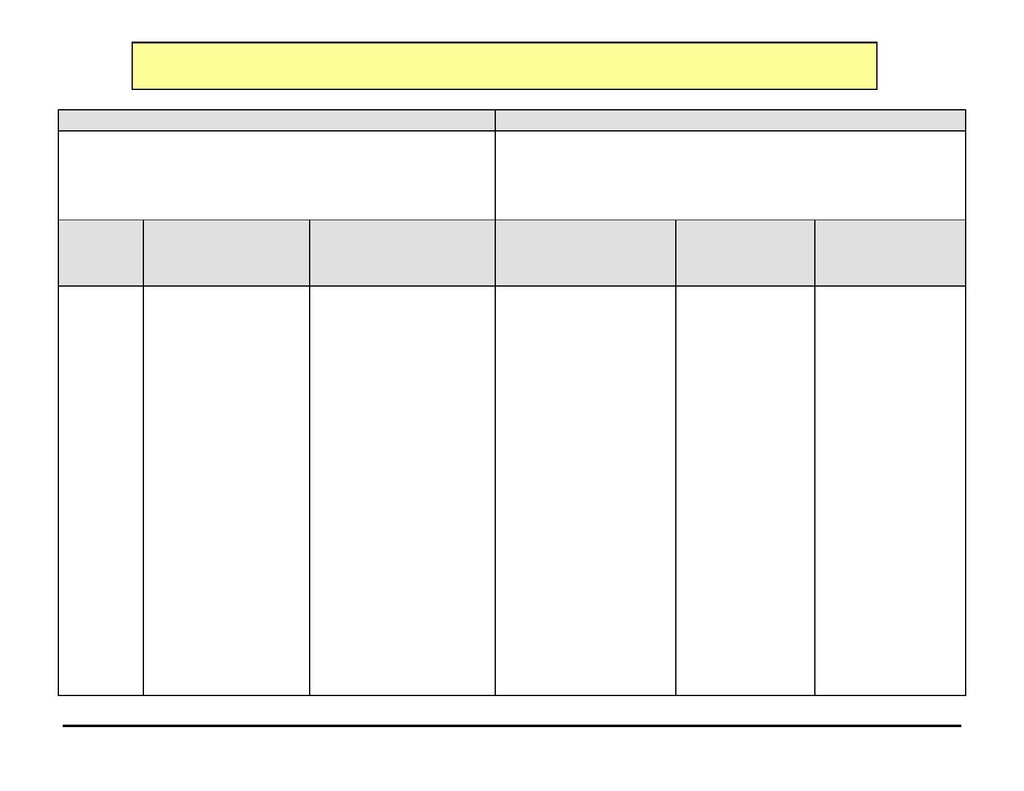
Greenwich-Stow Creek Partnership Schools
Content Area: Spanish Course/Grade: 8th

Big Ideas Standard
Language and culture are mutually interdependent
World Languages

Unit/Pacing Enduring Essential Questions Areas of Focus Assessments Program Components
Understandings (Indicators) (Learning Activities)

Unit # 1 Unit # 9
Unit 2
Unit #4 Unit # 9 Unit# 7

Learning about
different cultures will
lead to a better
understanding of
one's own culture.

Acquiring a second
language will result in
developing a better
knowledge of the student's primary language.

How can learning a second
language help students better learn their primary language?

How can learning about
different Hispanic cultures
help students better learn
their own culture?

How can learning vocabulary
related to (colors, food,
numbers, and body parts),
help students better
understand primary language and categorize information?

How can expanding
vocabulary help to build a
foundation for dialogue and
fluency?

•

•

•

Research the
accomplishment s and biography
of a famous
Hispanic person in celebration of
Hispanic
Heritage Month

Research
information
about a Spanish
speaking
country. Obtain details about the
country's
geography,
climate, culture,
etc

Learn to identify
and label
numbers, colors, professions, and

Rubric for Famous Hispanic Person.

Rubric outlining a list
of areas to be
researched related to the Spanish speaking country.

Draw and
Label information
learned and present it to the class.

Design a menu
featuring Hispanic food in Spanish.

Design a three
dimensional house in a shoe box.

Oral assessments and class discussions.

•

•

•

Students will
research
information in the internet. Use clip art
and/or
drawings to
illustrate their findings.
Present the
information to the class.

Students copy
power point
presentation on food.
Students work
in pairs to
discuss
food likes and dislikes in the
target
language.

Greenwich-Stow Creek Partnership Schools 6 2013

Big Ideas Standard
Language and culture are mutually interdependent
World Languages

Unit/Pacing Enduring Essential Questions Areas of Focus Assessments Program Components
Understandings (Indicators) (Learning Activities)

•

•

•

•

food and body
parts

Expand
vocabulary
words related to
furniture and transportation

Practice greeting
s and common
expressions

Experience
Hispanic
folktales and literature and
acquire
knowledge of
various Hispanic
cultures

Acquire
vocabulary
related to

Role playing skits.

Performance assessments.

Project presentations in power point.

•

•

•

Students will play "Simon says…"

Kinesthetic
activities
such as
games and songs will
enhance
and
reinforce
knowledge
through games.

Draw and
label
informatio
n learned
and present
it to the class.

Greenwich-Stow Creek Partnership Schools 7 2013

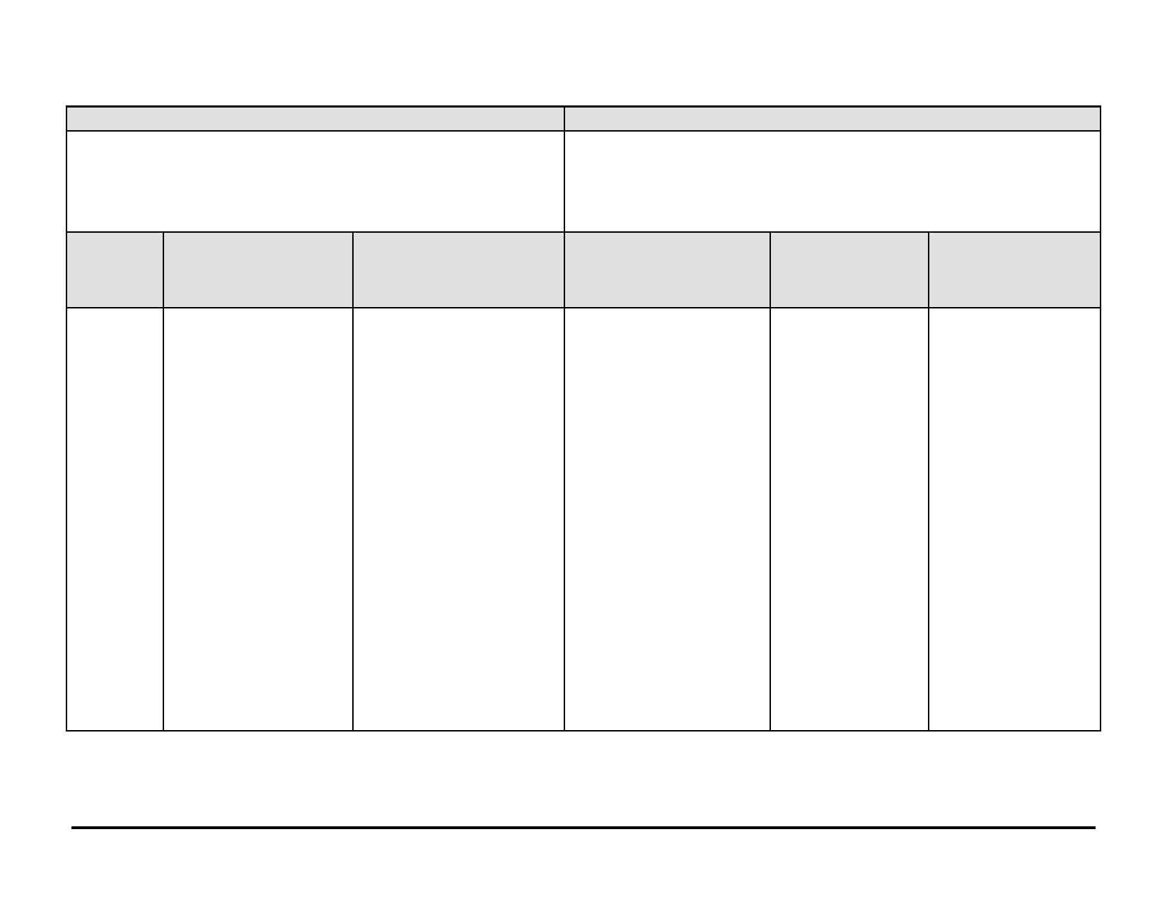
Big Ideas Standard
Language and culture are mutually interdependent
World Languages

Unit/Pacing Enduring Essential Questions Areas of Focus Assessments Program Components
Understandings (Indicators) (Learning Activities)

community • Role
places and playing
things likes and
dislikes
related to food for
breakfast, lunch and dinner.

• Drawing
and
labeling
information learned and presenting
it to the class.

Greenwich-Stow Creek Partnership Schools 8 2013

